ABS INTERN

OBJECTIVE : To create a simple dashboard using Next.js,Node.js,MongoDB.

GITHUB LINK : <https://github.com/GKalaiselve/Alphasolutions>

HOME PAGE:

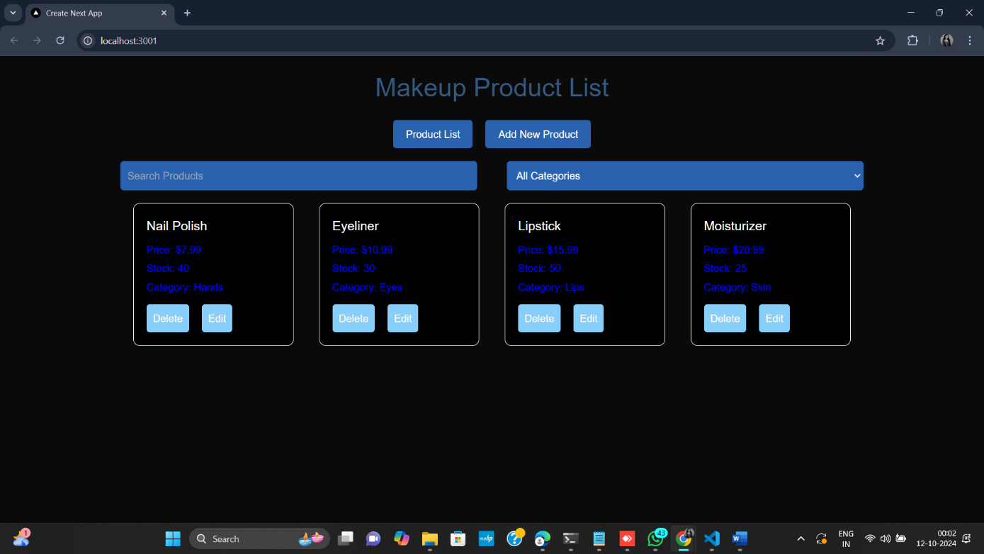

ADD NEW PRODUCT:

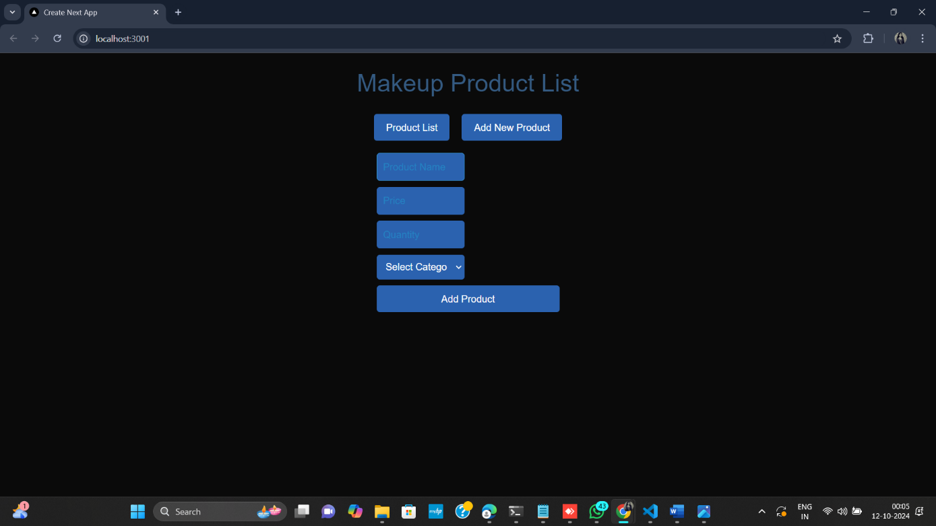

Before Adding new product:

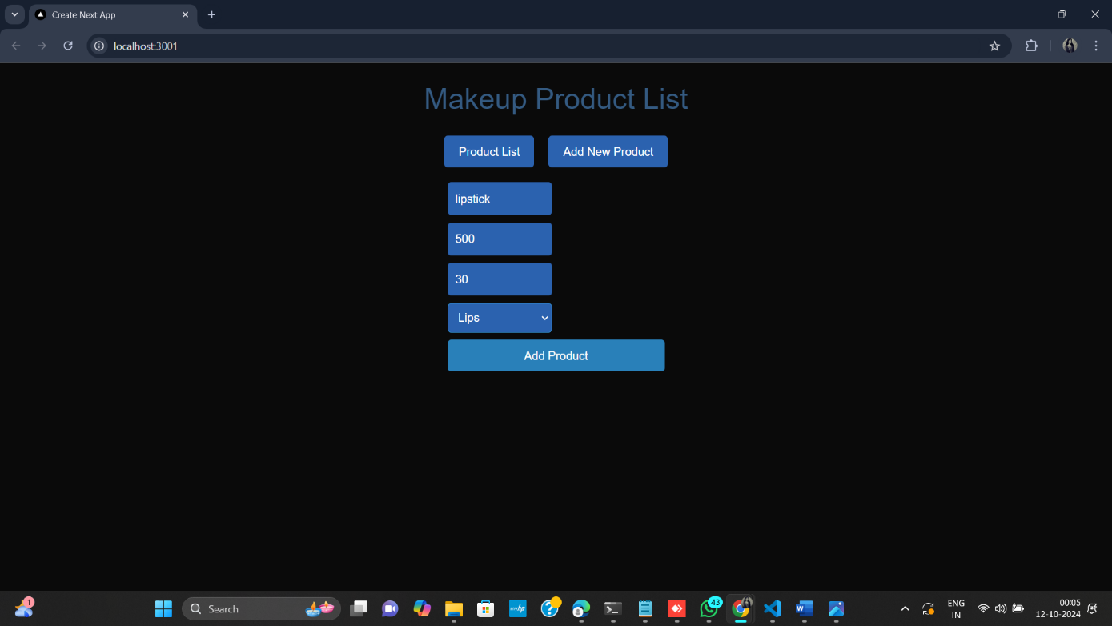

After Adding :

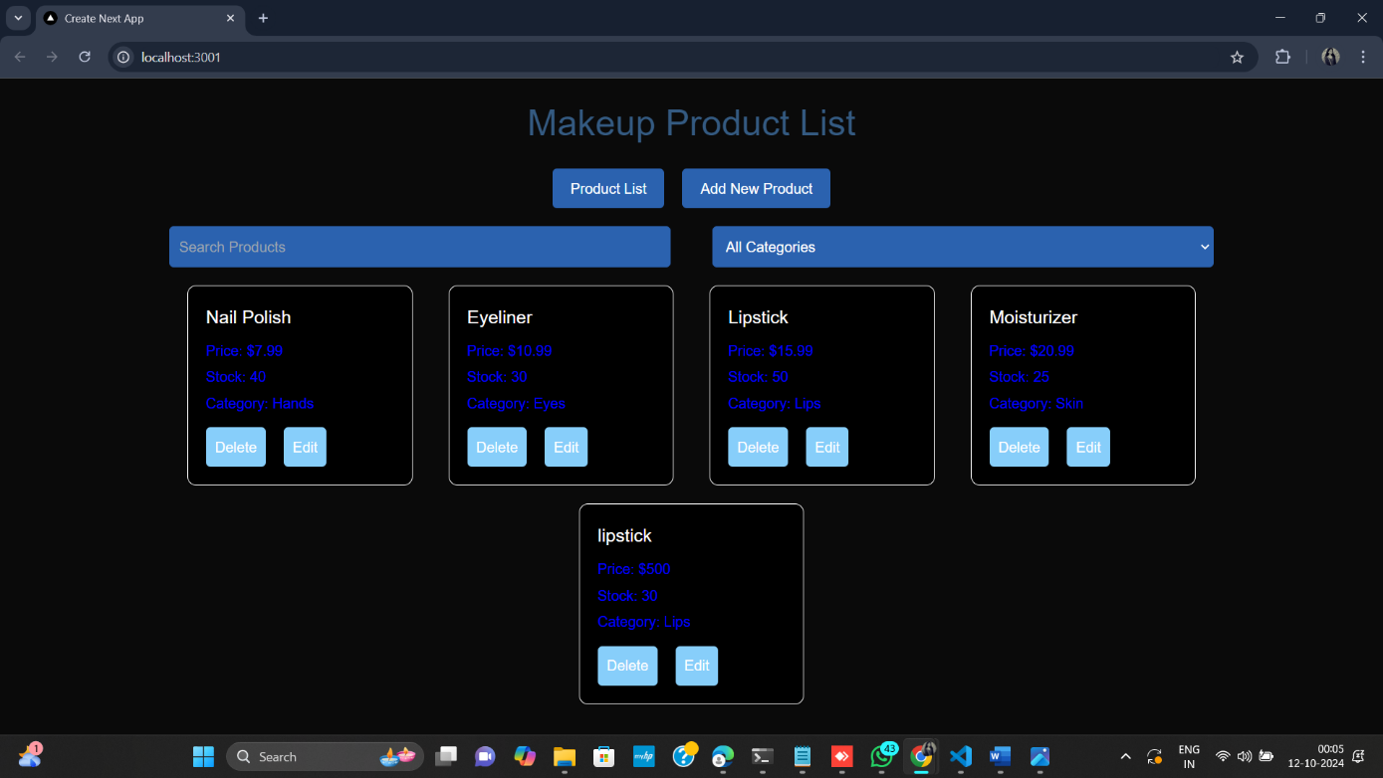

# To Edit :

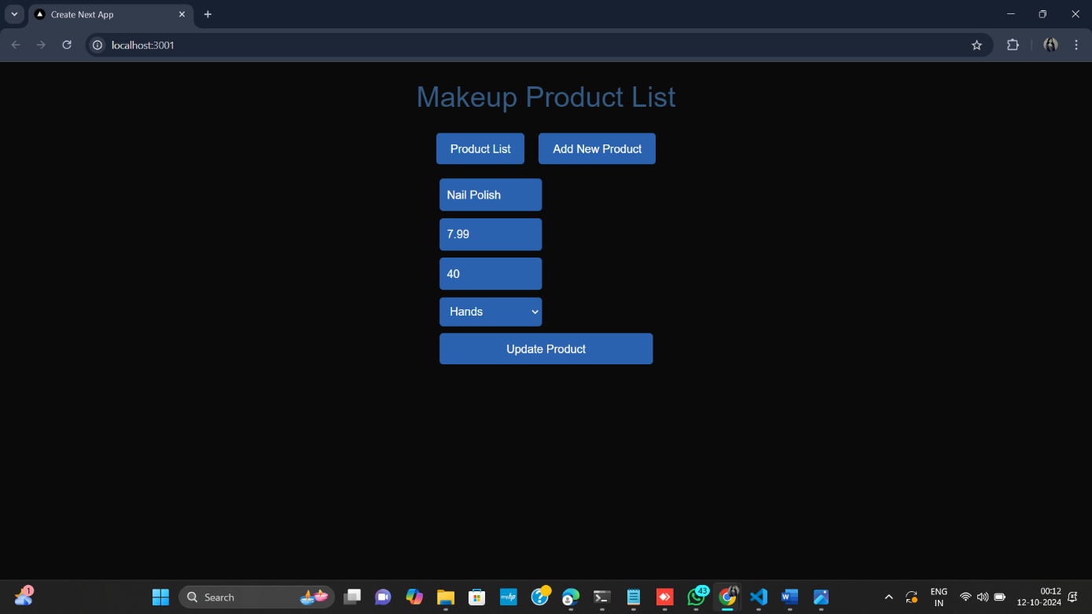

# After Editing the product :

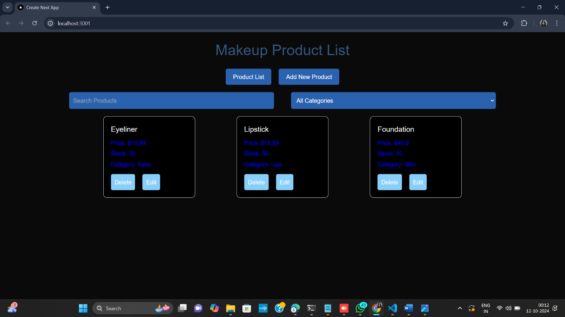

# To Deleting the product :

